
GENBE302 – BASICS OF ELECTRICITY
`

DATE: …/…/2025

PERIOD: TERM II

TECHNICAL SECONDARY SCHOOLS (TSS)
END OF TERM II EXAMINATIONS: 2024-2025
MARKING GUIDES
(ANSWER WITH MARKS ALLOCATIONS)
SECTOR: ICT AND Multimedia

TRADE NAME: Networking and Internet Technologies
RQF LEVEL: 3
MODULE TITLE: BASICS OF ELECTRICITY
…………/100
MARKS:
DURATION: 3 HOURS
INSTRUCTIONS TO CANDIDATES:
This Exam paper is composed of Twenty-four (24) questions distributed in Three Sections (A, B, C). Follow the instructions given below, and answer the indicated questions in each section for a total of 100marks
Section A: Seventeen (17) questions, all are Compulsory. 55 marks
Section B: Five (5) questions, choose and answer any three (3). 30 marks
Section C: Two (2) questions, choose and answer any one (1) 15 marks
Allowed Materials: Blue pen, Ruler, Calculator, Pencil, (Fitting with the exam paper)

- What is the unit of electric current?
a) Volt
b) Ampere
c) Ohm
d) Watt
Answer: b) Ampere (2Marks)
- Which of the following is true about Ohm's Law?
a) V=I×RV = I \times RV=I×R
b) P=I×RP = I \times RP=I×R
c) I=V×RI = V \times RI=V×R
d) V=I+RV = I + RV=I+R
Answer: a) V=I×RV = I \times RV=I×R (2Marks)
- Which of the following is NOT a type of electric waveform? a) Sine wave
b) Square wave
c) Circular wave
d) Sawtooth wave
Answer: c) Circular wave (2Marks)
- What is the peak value of an AC voltage waveform with an RMS value of 10V?
a) 10V
b) 14.14V
c) 20V
d) 7.07V
Answer: b) 14.14V (2Marks)
- Kirchhoff's Current Law (KCL) states that:
a) The sum of all voltages around a closed loop equals zero.
b) The sum of currents entering a junction equals the sum of currents leaving.
c) The sum of all powers in a circuit equals zero.
d) The current is inversely proportional to the resistance.
Answer: b) The sum of currents entering a junction equals the sum of currents leaving (2Marks)
- Which theorem states that the maximum power is transferred when the load resistance equals the source resistance?
a) Thevenin's Theorem
b) Norton’s Theorem
c) Superposition Theorem
d) Maximum Power Transfer Theorem
Answer: d) Maximum Power Transfer Theorem (2Marks)
- In a series RLC circuit, what happens when the circuit reaches resonance? a) The impedance is zero.
b) The current is maximum.
c) The voltage is zero.
d) The phase angle is 90°.
Answer: b) The current is maximum. (2Marks)
- What is the unit of power in an electrical circuit?
a) Ohm
b) Volt
c) Ampere
d) Watt
Answer: d) Watt (2Marks)
- Which of the following materials is considered ferromagnetic?
a) Aluminum
b) Copper
c) Iron
d) Gold
Answer: c) Iron
(2Marks)
- What is the primary function of a transformer?
a) To store energy
b) To increase or decrease voltage
c) To convert DC to AC
d) To generate electricity
Answer: b) To increase or decrease voltage
(2Marks)
True or False
- The unit of electric current is Ampere.
Answer: True
(3Marks)
True or False
- In a parallel RLC circuit, resonance occurs when the impedance is at its maximum.
Answer: False (In a parallel circuit, resonance occurs when the impedance is at its minimum.) (3Marks)
True or False
- Kirchhoff’s Voltage Law states that the sum of all currents in a circuit must be equal to zero.
Answer: False (This is Kirchhoff’s Current Law. KVL states that the sum of all voltages in a closed loop is zero.) (3Marks)
True or False
- A step-up transformer increases voltage and decreases current.
Answer: True (3Marks)
True or False
- The RMS value of an AC waveform is the same as its peak value.
Answer: False (The RMS value is smaller than the peak value. RMS is the peak value divided by √2.) (3Marks)

- Match the term to the correct definition.
Term | Definition
1. Ohm’s Law | a) The sum of voltages around a loop equals zero.
2. Kirchhoff’s Voltage Law | b) Relationship between voltage, current, and resistance in a circuit.
3. Peak Value | c) The maximum value of an AC waveform.
4. Resonance in RLC Circuits | d) Occurs when the impedance is at a minimum in a parallel RLC circuit.
5. Thevenin’s Theorem | e) Replaces a complex network with a single voltage source and series resistance.
Answer:
- Ohm’s Law → b) Relationship between voltage, current, and resistance in a circuit.
- Kirchhoff’s Voltage Law → a) The sum of voltages around a loop equals zero.
- Peak Value → c) The maximum value of an AC waveform.
- Resonance in RLC Circuits → d) Occurs when the impedance is at a minimum in a parallel RLC circuit.
- Thevenin’s Theorem → e) Replaces a complex network with a single voltage source and series resistance.
(10Marks)
- Match electrical quantities with their definitions in a table below
ANSWERS ELECTRICAL | ANSWERS ELECTRICAL | ANSWERS ELECTRICAL
1=E | 1. Power | A. describes the “pressure” that pushes electricity
2=D | 2. Energy | B. refers to the flow of electricity in an electronic circuit, and to the amount of electricity flowing through a circuit.
3=A | 3. Voltage | C. is a measure of the opposition to current flow in an electrical circuit.
 |  | D. is the power an atom's charged particles have to cause an action or move an object.
 |  | E. measures the rate of electrical energy transfer by an electric circuit per unit of time.
(10Marks)
- In the combination circuit sketched below, find:

- The equivalent resistance for the circuit.

- The total current through the circuit.

The current through each individual resistor
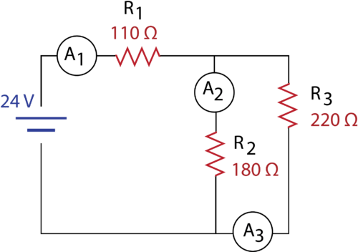
Answer:

a) We start by simplifying the parallel resistors R2 and R3

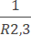=+ (1mark)

= +

=

R2,3=99Ω (1 mark)
We then simplify R1 and R2,3 which are in series R_{T}=R₁₊R_{2,3} (1 mark)
=99Ω+110Ω

= 209Ω (1 mark)

b) We can then find the total current (I_{T)=} (1 mark)

I_{T}=24V/209 Ω

=0.11A (1mark)

C) All the current must pass in R1
The voltage drop through R1 is V1=R1 X I1 (1mark)
=110 Ω X 0.11A
=12.1 V (1mark)
Therefore, Voltage drops through R₂ and R₃ is equal to 24V- 12.1V=11.9V
(1mark)

(10marks)
- In the following schematic diagram, find the total current (I).

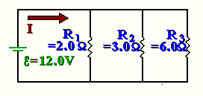
Answer:
We know the total potential of this circuit,

= 12.0 V

So, between points A and B, the potential must drop 12.0V. Also, the potential drops across branches of a circuit are equal. That is,

(1 mark)

We can use Ohm's Law

V = IR

Or

I = V/R (1mark)

To find the current across each resistor.
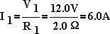

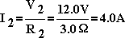

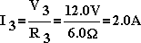

Recall that the currents through branches of a parallel circuit add to give the total current. That is, the total current 'splits up' so that part of the total current travels down each branch. So, adding up the three currents, we get:

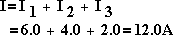

So, the total current is I = 12.0A. (2marks)

(10marks)
- A 100 W electric light bulb is connected to a 250 V supply. Determine (a) the current flowing in the bulb, and (b) the resistance of the bulb
Answer:

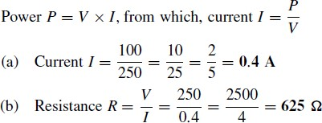 (10marks)

- Explain The main characteristics of a series circuit
Answer:
- same current flows through all parts of the circuit.
- different resistors have their individual voltage drops.
- voltage drops are additive.
- applied voltage equals the sum of different voltage drops.
- resistances are additive.
- powers are additive.

(10marks)
- For the circuit shown in Figure below, determine (a) the battery voltage V, (b) the total resistance of the circuit, and (c) the values of resistance of resistors R1, R2 and R3, given that the
p.d.’s across R1, R2 and R3 are 5 V, 2 V and 6 V respectively.

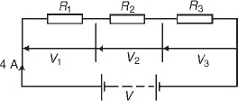
Answer:

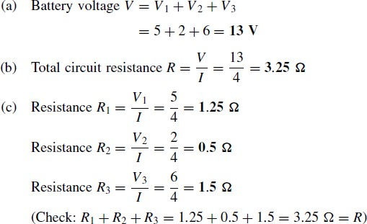 (10marks)

- Determine the current in the 5Ω resistance of the network shown in Figure below using Norton’s theorem and Thevenin’s theorem. Hence find the currents flowing in the other two branches
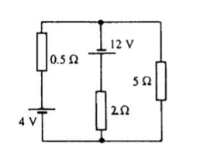

Answer:
By using Thevenin theorem Following the procedure: (i)The 5Ω resistance is removed from the circuit as shown in Fig.(a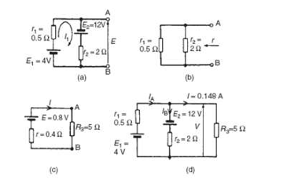
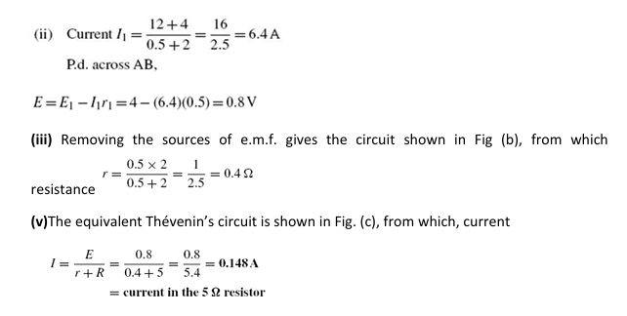
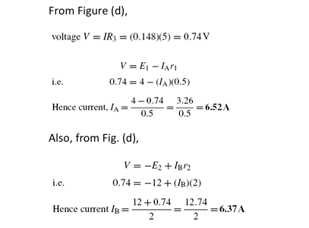
(15marks)
- Figure below shows a circuit containing two sources of e.m.f., each with their internal resistance. Determine the current in each branch of the network by using the superposition theorem.
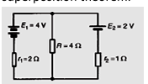
Answer:
Procedure: 1. Redraw the original circuit with source E2 removed, replaced by r2 only, as shown in Figure(a) below
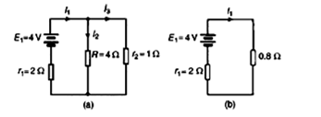
Label the currents in each branch and their directions as shown in Figure (a) and determine their values. (Note that the choice of current directions depends on the battery polarity, which, by convention is taken as flowing from the positive battery terminal as shown) R in parallel with r2 gives an equivalent resistance of (4×1)/(4+1)=0.8Ω From the equivalent circuit of Figure (b),
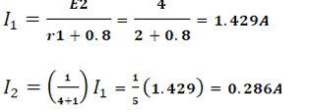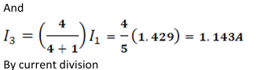
3. Redraw the original circuit with sourceE1 removed, being replaced by r1 only, as shown in Figure below (a)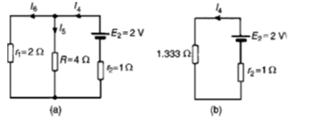
4. Label the currents in each branch and their directions as shown in Fig. 13.18(a) and determine their values. r1 in parallel with R gives an equivalent resistance of (2×4)/(2+4)=8/6=1.333Ω From the equivalent circuit of Figure (b)
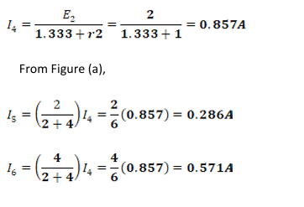
- Superimpose Figure (a) in step 3 on to Fig. (a) in step 1
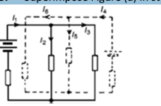
7.Determine the algebraic sum of the currents flowing in each branch. Resultant current flowing through source 1, i.e.
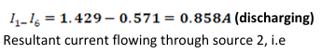
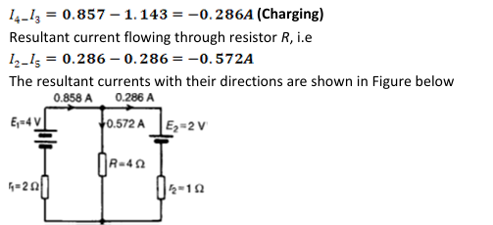
(15marks)

______END OF ASSESSMENT_________

